INDIVIDUAL ASSIGNMENT 1

AHMAD SOLEHIN BIN SHARUDDIN CB15003

SECTION 02G

TECHNOPRENEURSHIP | UGE2002

***Profile successful entrepreneurs***

***Malaysia Entrepreneur***

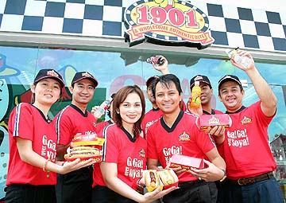

In a given assignment 1 , I have received inspiration and ideas **Tengku Rozidar Tengku Zainal Abidin**, Co-Founder & Executive Chairman, 1901 Hotdog entrepreneurs choose to be a model.

|  |  |
| --- | --- |
| Name: | Tengku Rozidar Tengku Zainal Abidin |
| Title: | Chief Executive Officer |
| Company: | Nineteen O One Sdn Bhd (1901 Hotdogs) |
| Company Size: | [Expected] MYR12 million (USD 4 mil) @ 2007 |
| Growth Forecast: | 20% this year and onwards |
| Website: | www.1901.com |
| Industry: | Food and Beverages |
| Number of outlets: | Locally, 74 (majority operated by franchisees), 3 international outlets |
| Country: | Malaysia |

|  |
| --- |
| Education Background: |
| MA International Relations (UK); BA in English Literature (Canada); Bachelor in Education (Canada) |
| Company’s Goals: |
| To achieve multi-faceted success while considering  1. The effect of our products on the health and well-being of our customers (and our staff),  2. The impact that our business practices and choices will have on the environment. |

**DONATION**

* Rozidar Tengku Tengku Zainal Abidin hotdogs based business started even though it is quite foreign in the community in this country.
* He was mortgaging jewelry and luxury cars just to settle the debt for the business.
* Program helps homeless people by donating food.

**RESULTS**

* Tengku Rozidar first obtains a business license, Candy Bouquet franchise.
* Tenfku Rozidar 1901 establishing hotdogs, hotdogs franchise companies that are increasingly recognized in Malaysia.
* He has 48 branches across the country hotdogs 1901 and expected number will increase to 71 by the end of this year.
* Tengku Rozidar produces their own recipe sausages, sauces and extra ingredients into the identity of the 1901 hotdogs.
* Branch 1901 hotdogs he can be found at selected oil companies and cinemas.
* Successful in recovering the nearly 1901 hotdogs position in the long wavered almost a year.
* Receive recognition as one of the 'Super brands' in Malaysia and the Franchisor Expectation in 1998 by the Malaysian Franchise Association.
* Recognized by the Malaysia Book of Records as the largest hot dog chain in the country

**CHALLENGES**

* Business plunged the economy collapses.
* Hotdogs Company has hit financial difficulties in 1901.
* "The situation was repeated again last year, causing 1901 branches in Singapore and Indonesia was closed,'' he said.
* He had to stop a number of employees in order to pull the financial expenses.
* He was faced with the problem of dishonest employees, particularly those involving financial matters.